College Placement Analysis

Project submitted to the

APSSDC

Bachelor of Technology
In
Computer Science and Engineering
School of Engineering and Sciences

Submitted By
M. Gangothri– 23MD1A0568
M.V.S. Jyothsna - 23MD1A0562
P. VaraLakshmi - 23MD1A0583
P. Lakshmi Sanjana -23MD1A0587
R. Poojitha -23MD1A0593


Under the guidance of
K.Narmada Mani
k.Meenakshi
May - july 2026

ABSTRACT :

The College Placement Analysis project is developed to analyze student placement data and identify the key factors that influence placement opportunities. The project uses Python programming along with data analysis and machine learning techniques to study placement trends among students. Various attributes such as CGPA, Branch, Internships, Gender, Placement Status, and Salary Package are considered for analysis.

The dataset contains information about 100 students. Data analysis techniques are used to understand placement patterns and visualize important insights through charts and graphs. A Random Forest Machine Learning model is implemented to predict whether a student is likely to be placed based on academic and internship performance.

The project helps educational institutions understand placement trends and provides valuable insights that can assist students in improving their placement opportunities. The results demonstrate the effectiveness of data analysis and machine learning in solving real-world educational problems.

INTRODUCTION :

College placements play an important role in the academic and professional growth of students. Educational institutions continuously strive to improve placement opportunities by analyzing student performance and identifying the factors that contribute to successful placements.

The College Placement Analysis project focuses on examining placement-related data to gain meaningful insights into student performance and placement outcomes. The project utilizes Python and various data analysis libraries to process, analyze, and visualize the data effectively.

Data analysis enables institutions to understand trends such as branch-wise placement rates, gender distribution, salary packages, and the impact of academic performance on placements. Machine Learning techniques further enhance the analysis by predicting placement chances based on student attributes.

This project demonstrates how modern data science tools can be applied in the education sector to improve placement strategies and support decision-making processes.

1.SYSTEM REQUIREMENTS:

Hardware Requirements
- Processor: Intel Core i3 or above

- RAM: 4 GB or above

- Hard Disk: 20 GB Free Space
- System Type: 64-bit Operating System

Software Requirements
- Operating System: Windows 10/11

- Python 3.x

- Jupyter Notebook

- Pandas Library

- NumPy Library

- Matplotlib Library

- Scikit-Learn Library

- Anaconda Distribution

•

ARCHITECTURE

The architecture of the College Placement Analysis project consists of multiple stages.

- Data Collection

- Placement dataset containing student information is collected.

- Data Loading

- The dataset is loaded using Pandas.
- Data Preprocessing

- Data is checked for missing values and prepared for analysis.

- Exploratory Data Analysis

- Statistical analysis and visualization are performed.

- Data Visualization

- Charts and graphs are generated using Matplotlib.

- Machine Learning Model

- Random Forest Classifier is trained using selected features.

- Prediction

- The trained model predicts placement chances.

- Results and Conclusion

- Insights and prediction results are analyzed and documented

- Machine Learning Model

- Random Forest Classifier is trained using selected features.

- Prediction

- The trained model predicts placement chances.

- Results and Conclusion
- Insights and prediction results are analyzed and documented.

USES OF DATA ANALYSIS

LIBRARY :

Pandas
Pandas is used for loading, managing, filtering, and analyzing the dataset. It provides powerful functions for handling structured data efficiently.

NumPy
NumPy is used for numerical computations and mathematical operations. It helps perform calculations quickly and efficiently.

Matplotlib
Matplotlib is used to create visual representations of data such as bar charts, pie charts, and scatter plots. It helps understand patterns and trends easily.

Scikit-Learn
Scikit-Learn is used for implementing Machine Learning algorithms. In this project, the Random Forest Classifier is used to predict student placement status.

Jupyter Notebook
Jupyter Notebook provides an interactive environment for writing, executing, and documenting Python code.

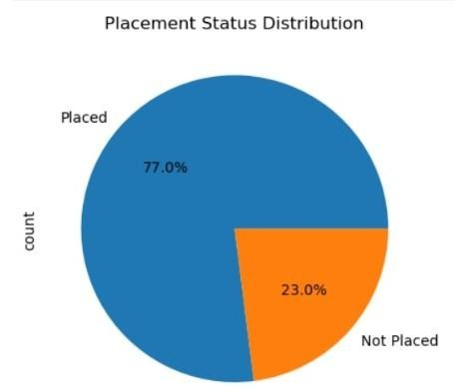
.

ADVANTAGES:

- Easy analysis of student placement data

- Identifies important factors affecting placements.

- Helps students understand placement requirements.

- Supports data-driven decision making.

- Provides graphical visualization of placement trends.

- Improves understanding of salary distribution patterns.

- Predicts placement chances using Machine Learning.

- Easy to implement and maintain.

- Reduces manual analysis effort.

. Useful for educational institutions and placement cells.

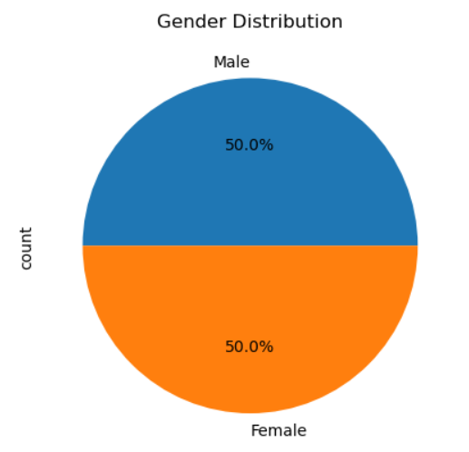
• .

CONCLUSION:

The College Placement Analysis project successfully analyzes placement-related data and provides valuable insights into student placement trends. The project utilizes Python, Pandas, NumPy, Matplotlib, and Scikit-Learn to perform data analysis, visualization, and machine learning-based prediction.

The analysis helps identify the impact of factors such as CGPA, Branch, and Internships on placement outcomes. Visualizations provide a clear understanding of placement statistics and salary trends. The Random Forest Machine Learning model effectively predicts placement chances based on student information.

Overall, the project demonstrates the practical application of data
analysis and machine learning techniques in the education domain. It can assist institutions and students in making informed decisions and improving placement performance

• .

